Name:Premkumar Garud

Roll No.:CS5-90

PRN:202401100001

Dataset:Covid-19 Dataset

import pandas as pd

import numpy as np

df = pd.read_csv('country_wise_latest.csv')

print("NUMPY OPERATIONS")

confirmed_array = df['Confirmed'].to_numpy()

print("1. Confirmed cases as NumPy array:", confirmed_array)

Output: 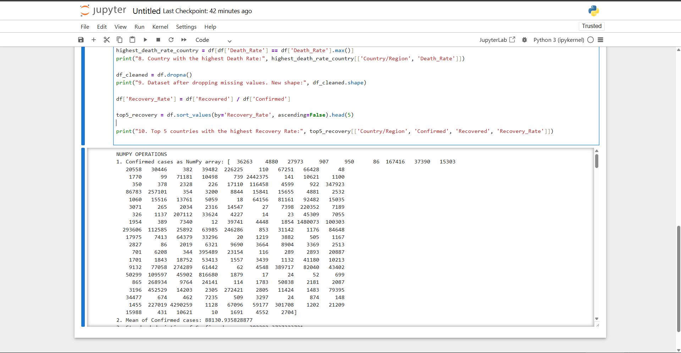

mean_confirmed = np.mean(confirmed_array)

print("2. Mean of Confirmed cases:", mean_confirmed)

Output: 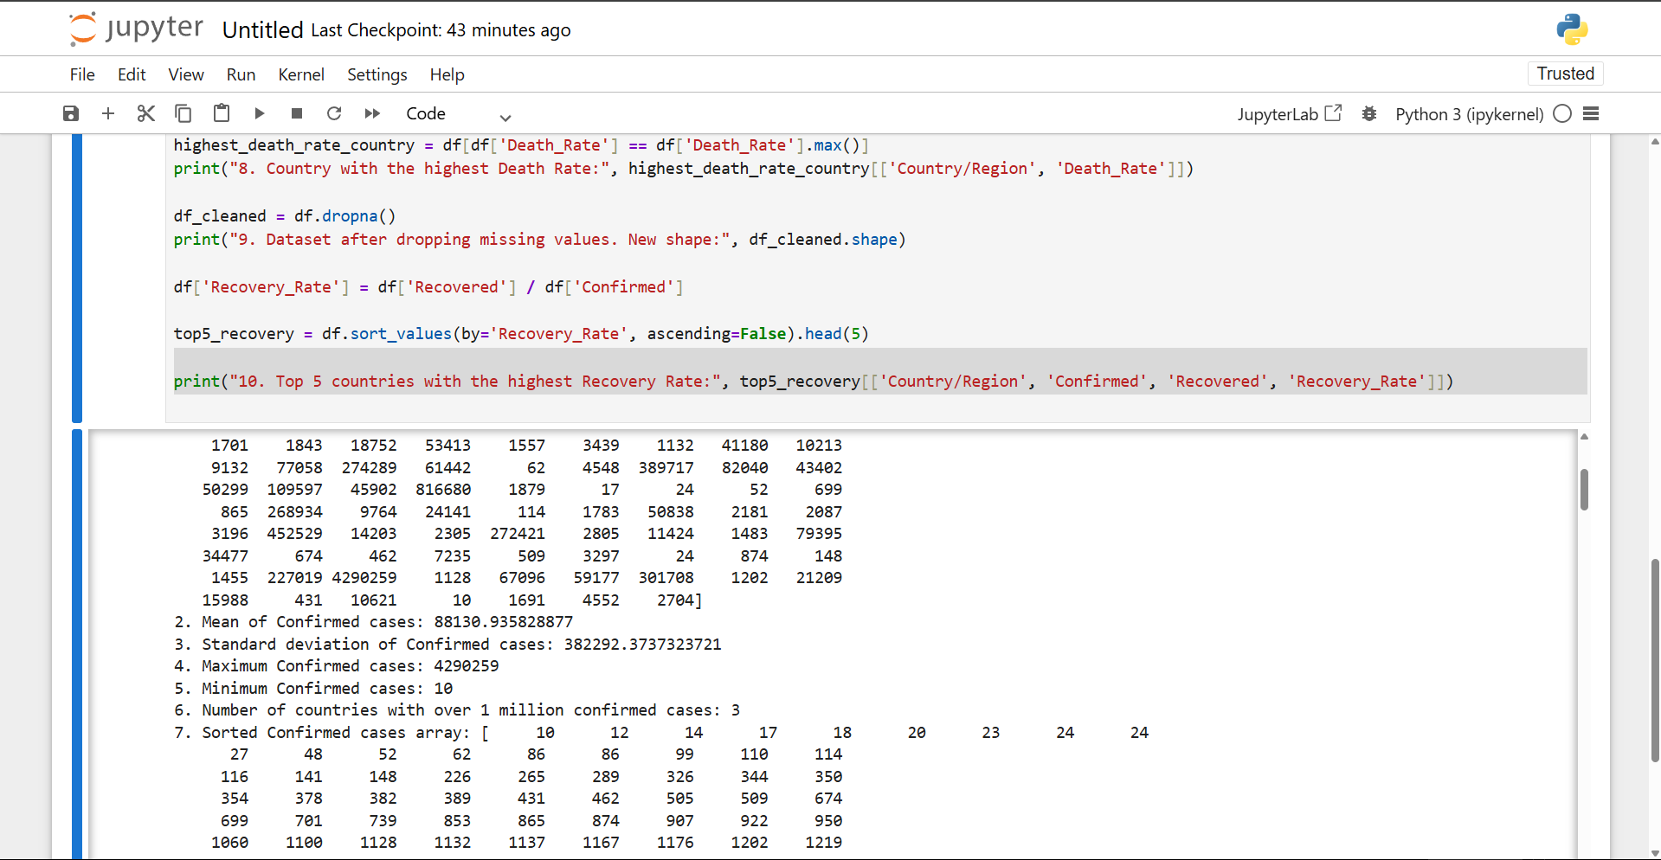

std_confirmed = np.std(confirmed_array)

print("3. Standard deviation of Confirmed cases:", std_confirmed)

Output: 

max_confirmed = np.max(confirmed_array)

print("4. Maximum Confirmed cases:", max_confirmed)

Output: 

min_confirmed = np.min(confirmed_array)

print("5. Minimum Confirmed cases:", min_confirmed)

Output: 

countries_over_million = np.sum(confirmed_array > 1_000_000)

print("6. Number of countries with over 1 million confirmed cases:", countries_over_million)

Output: 

sorted_confirmed = np.sort(confirmed_array)

print("7. Sorted Confirmed cases array:", sorted_confirmed)

Output: 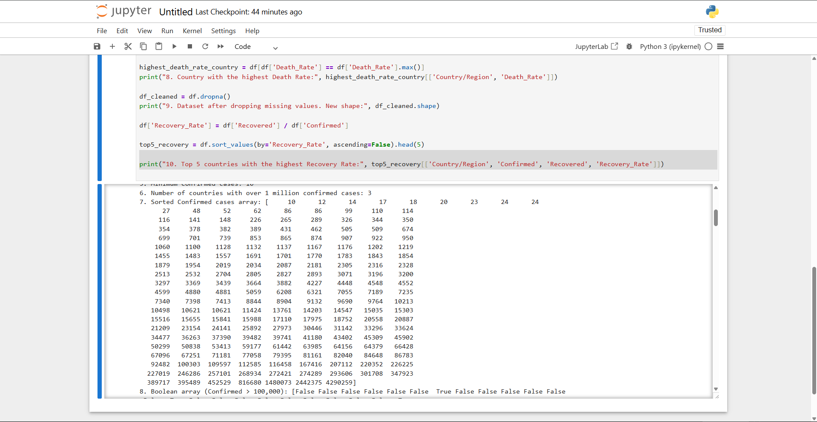

high_confirmed_bool = confirmed_array > 100_000

print("8. Boolean array (Confirmed > 100,000):", high_confirmed_bool)

Output: 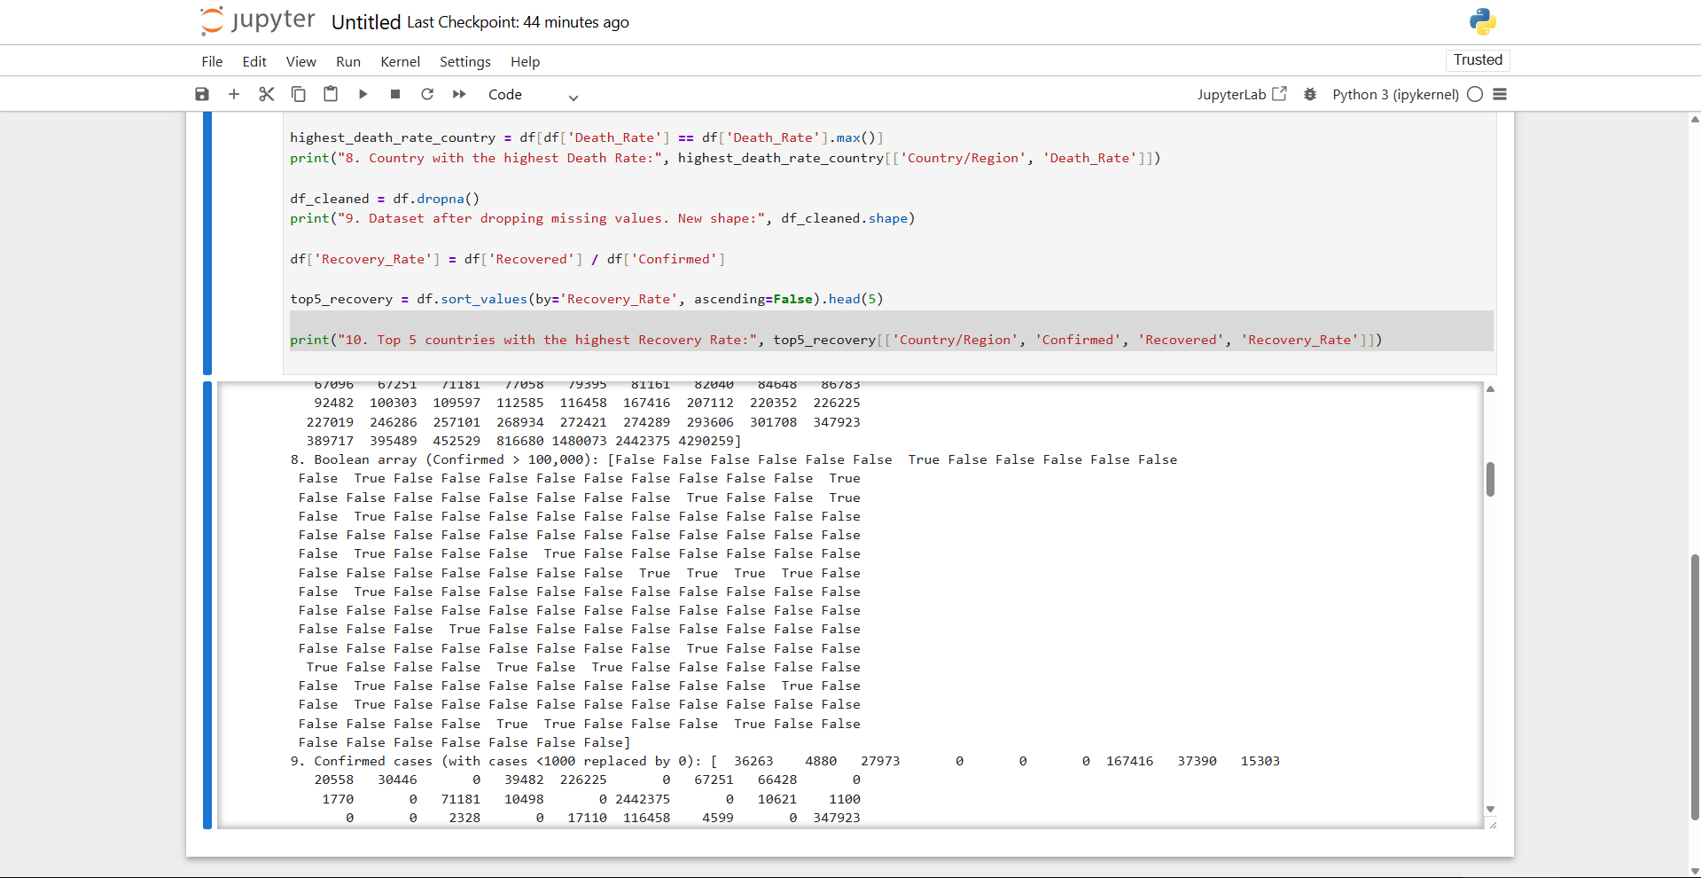

confirmed_replaced = np.where(confirmed_array < 1000, 0, confirmed_array)

print("9. Confirmed cases (with cases <1000 replaced by 0):", confirmed_replaced)

Output: 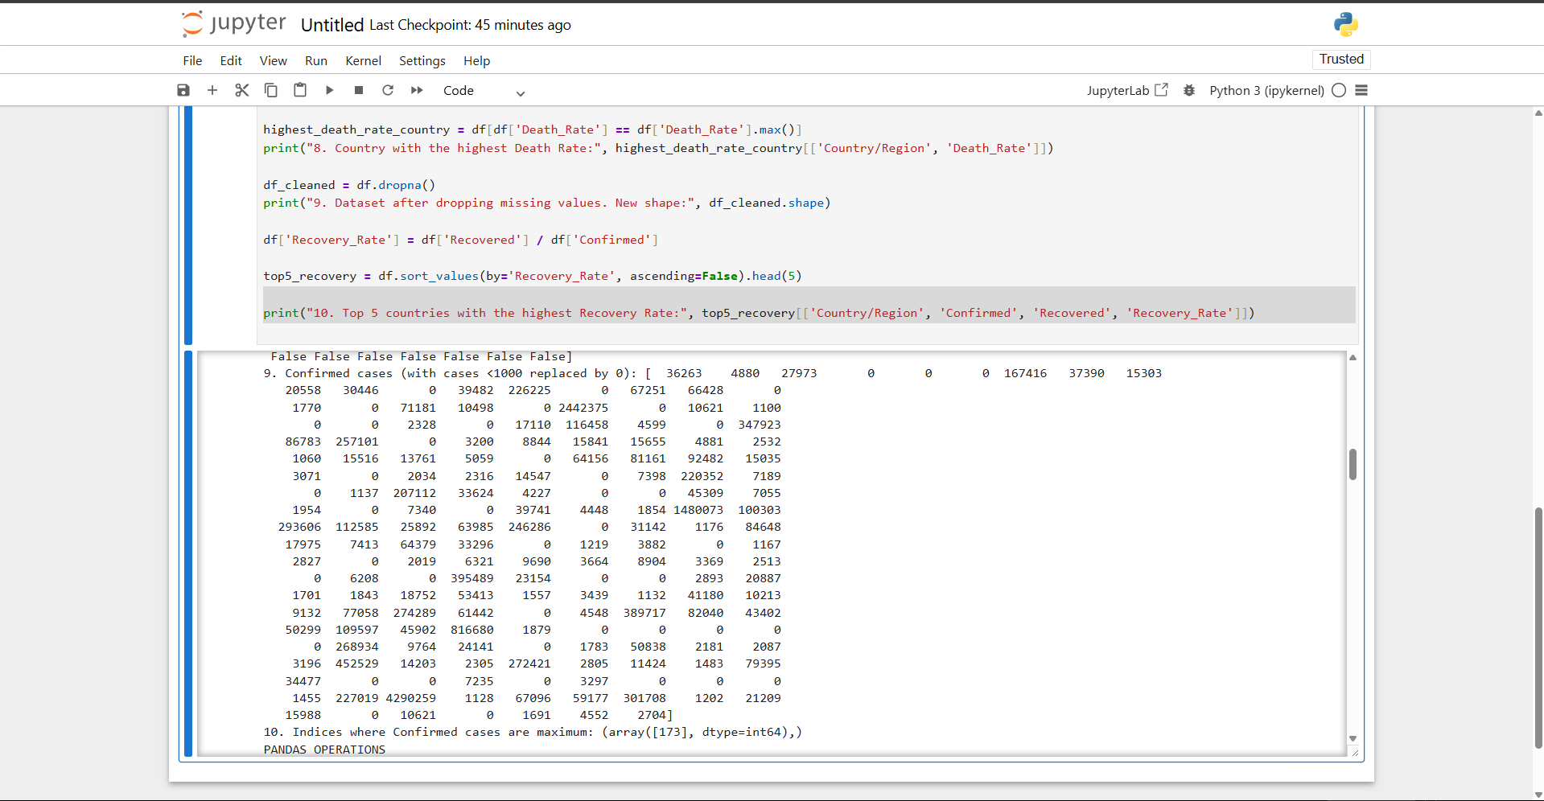

max_confirmed_indices = np.where(confirmed_array == np.max(confirmed_array))

print("10. Indices where Confirmed cases are maximum:", max_confirmed_indices)

Output: 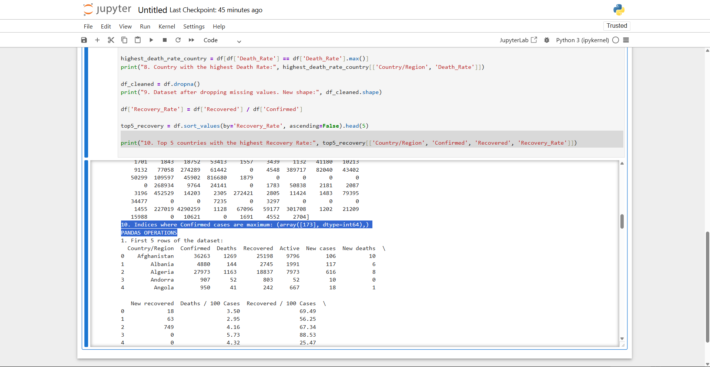

#Highlighted Portion includes output for 10th and the starting for pandas function

print("PANDAS OPERATIONS")

print("1. First 5 rows of the dataset:")

print(df.head())

output: 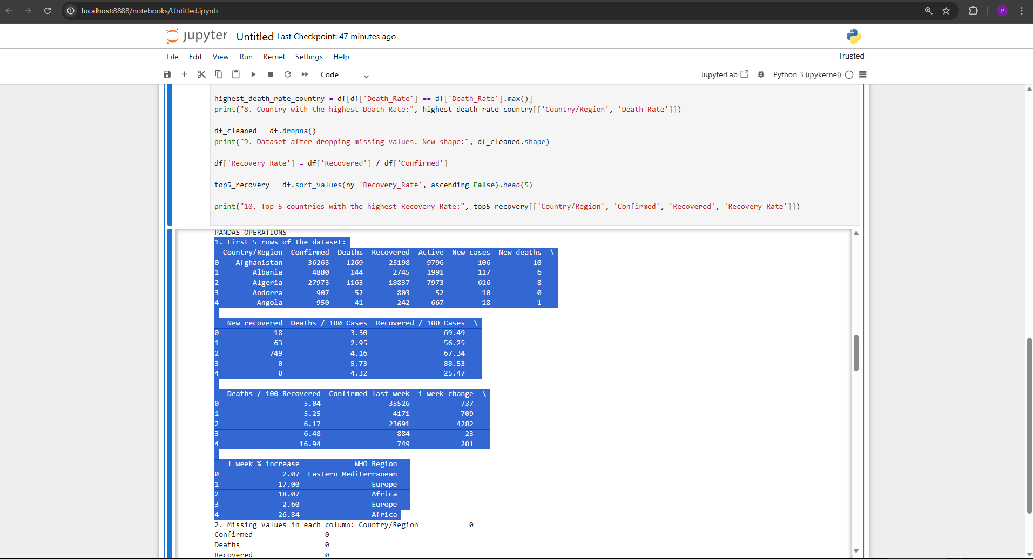

missing_values = df.isnull().sum()

print("2. Missing values in each column:", missing_values)

output: 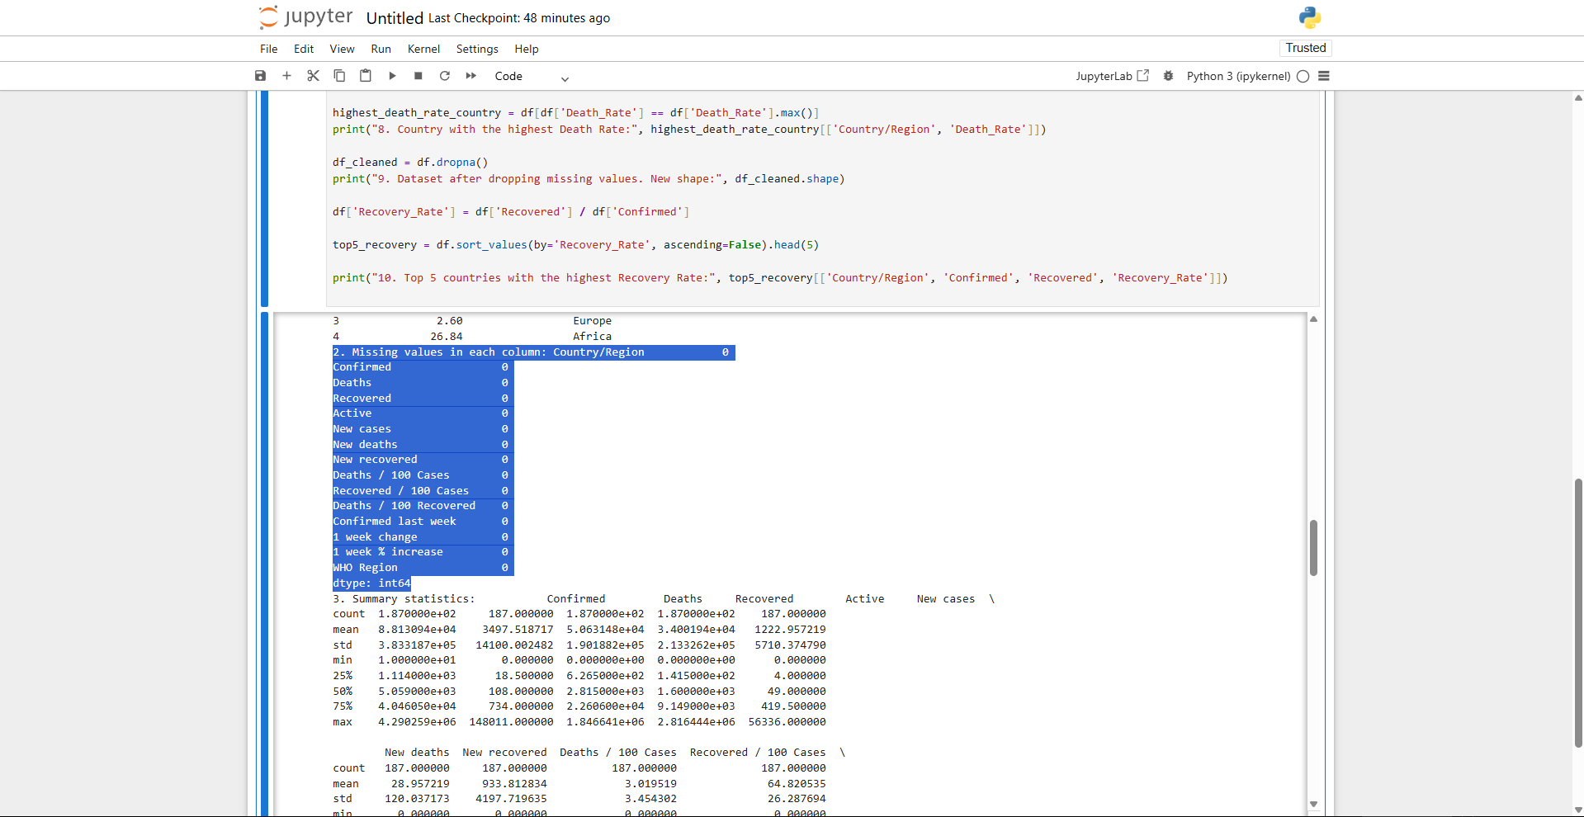

summary_stats = df.describe()

print("3. Summary statistics:", summary_stats)

Output: 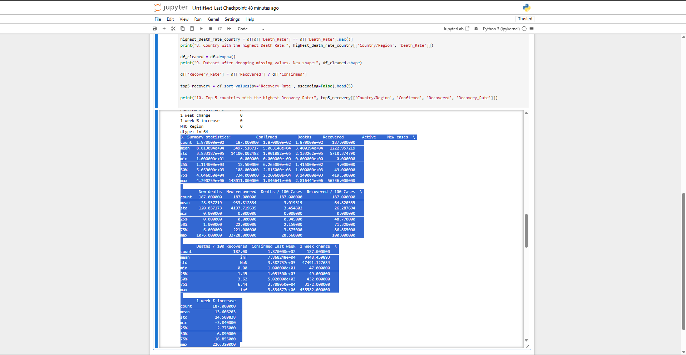

sorted_df_confirmed = df.sort_values(by='Confirmed', ascending=False)

print("4. Dataset sorted by Confirmed cases (top 5):", sorted_df_confirmed.head())

Output: 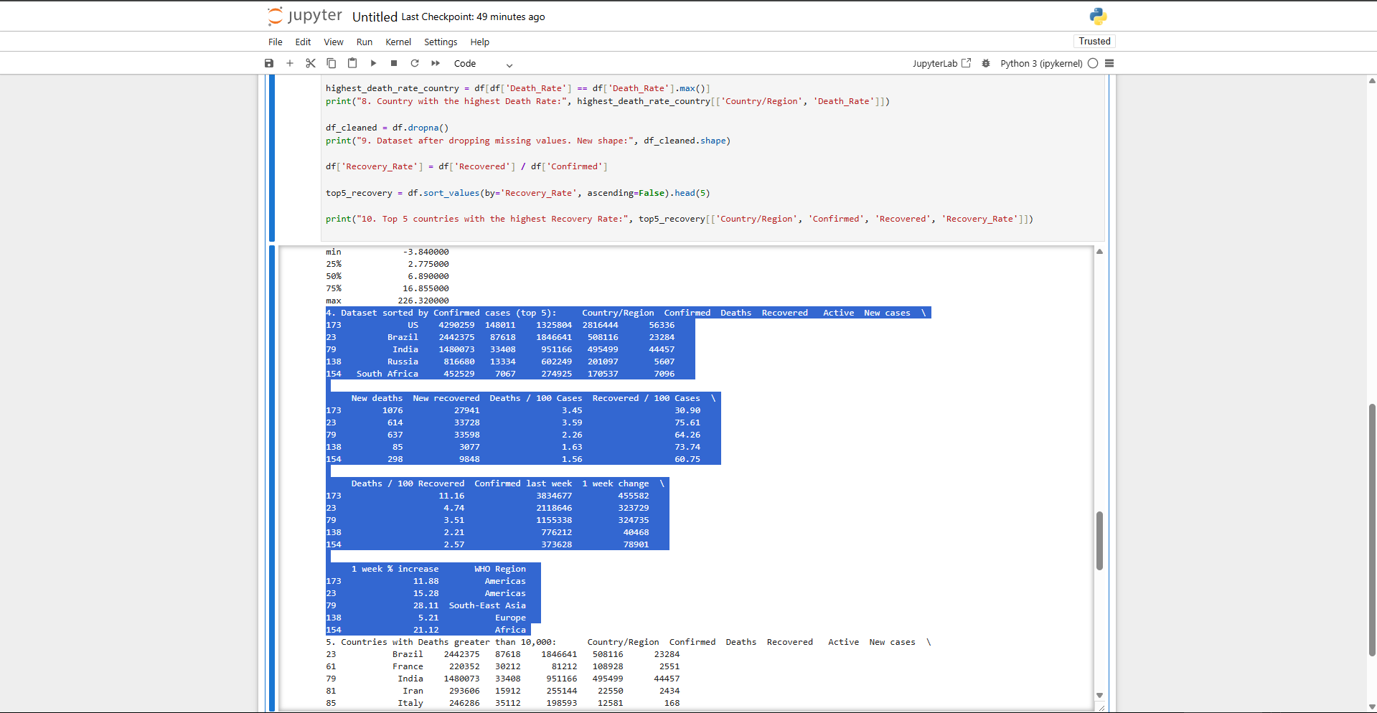

high_deaths_df = df[df['Deaths'] > 10000]

print("5. Countries with Deaths greater than 10,000:", high_deaths_df)

Output: 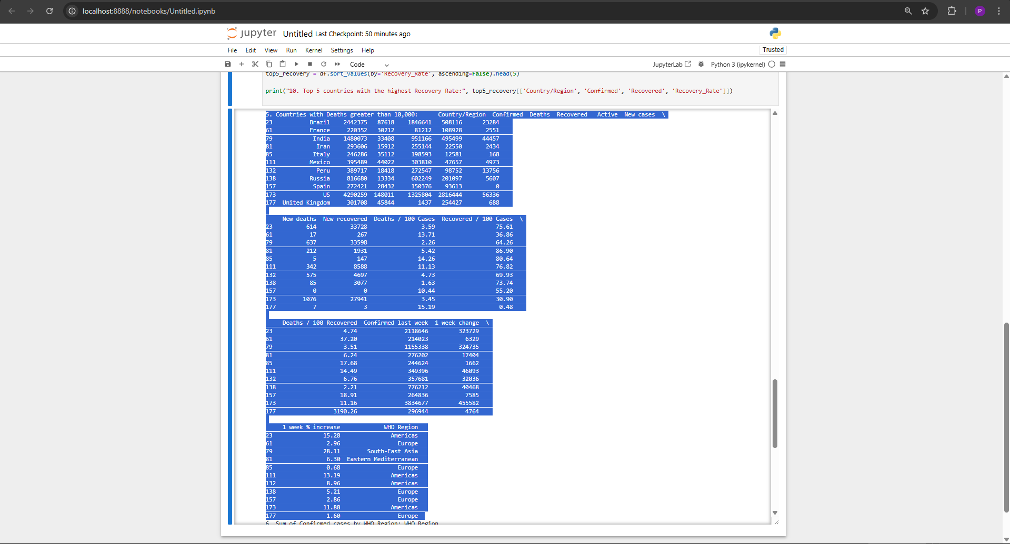

confirmed_by_region = df.groupby('WHO Region')['Confirmed'].sum()

print("6. Sum of Confirmed cases by WHO Region:", confirmed_by_region)

Output: 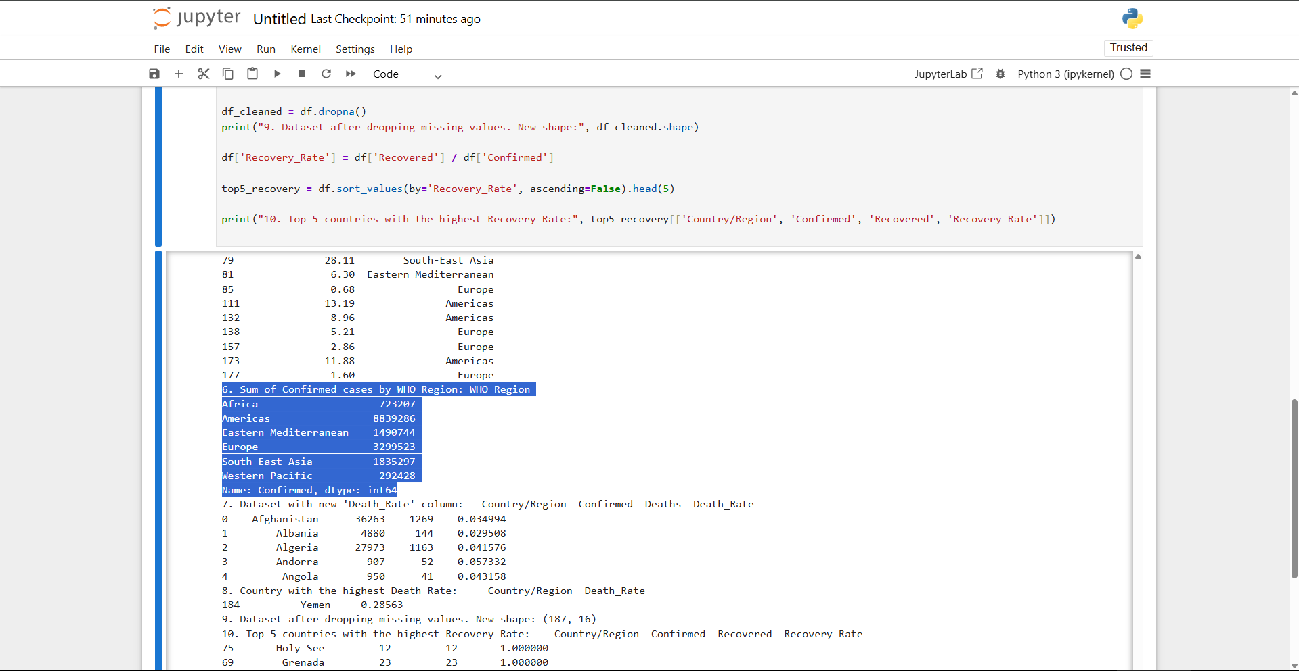

df['Death_Rate'] = df['Deaths'] / df['Confirmed']

print("7. Dataset with new 'Death_Rate' column:", df[['Country/Region', 'Confirmed', 'Deaths', 'Death_Rate']].head())

Output: 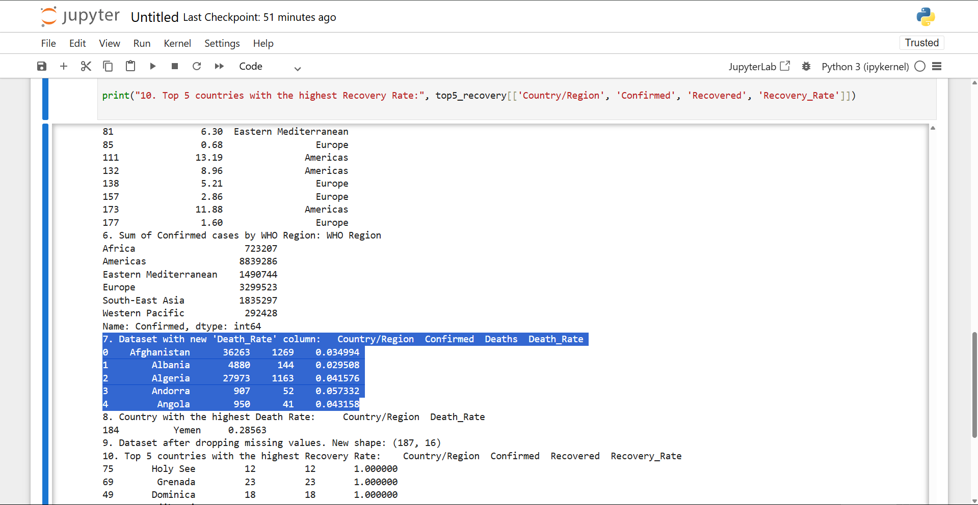

highest_death_rate_country = df[df['Death_Rate'] == df['Death_Rate'].max()]

print("8. Country with the highest Death Rate:", highest_death_rate_country[['Country/Region', 'Death_Rate']])

Output: 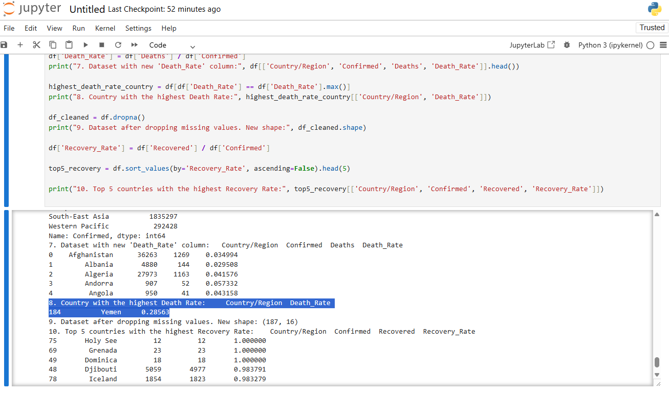

df_cleaned = df.dropna()

print("9. Dataset after dropping missing values. New shape:", df_cleaned.shape)

Output: 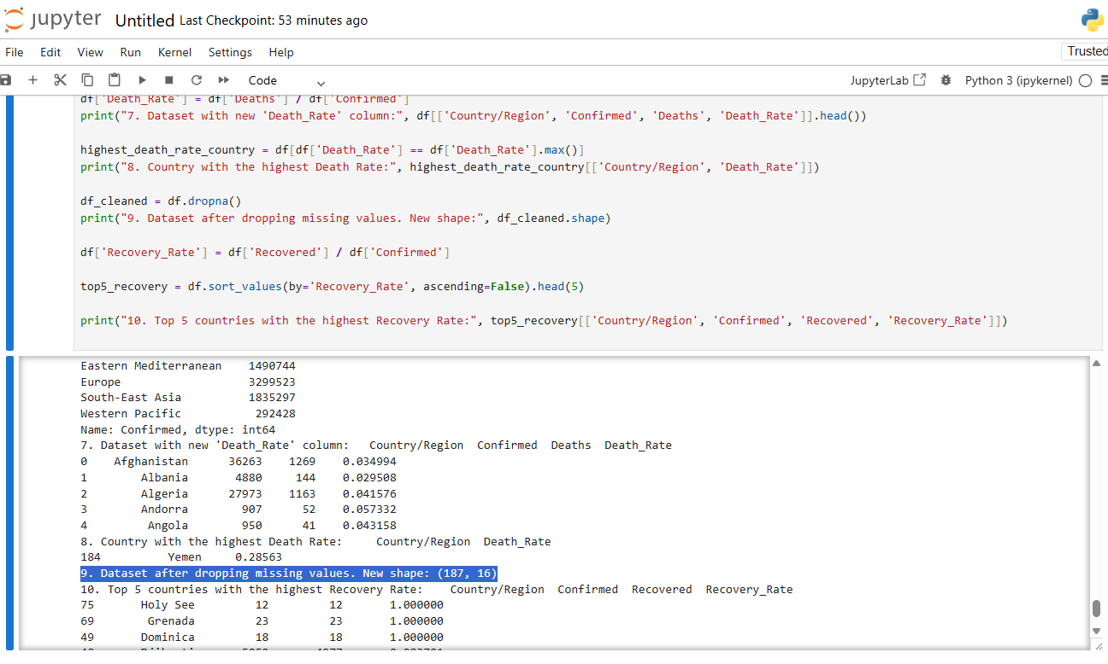

df['Recovery_Rate'] = df['Recovered'] / df['Confirmed']

top5_recovery = df.sort_values(by='Recovery_Rate', ascending=False).head(5)

print("10. Top 5 countries with the highest Recovery Rate:", top5_recovery[['Country/Region', 'Confirmed', 'Recovered', 'Recovery_Rate']])

Output: 